Programming with Python
By Deepak S (2527114)
Inventory Management
Introduction:
In any business, whether small or large, keeping track of products, supplies, and stock levels is a critical part of daily operations. An inventory management system helps organizations maintain accurate records of all their goods including details like product ID, name, price, supplier/dealer information, and available quantity. Without a proper system in place, businesses often face issues like overstocking, running out of essential items, or losing track of which dealer supplies which product. These problems can lead to financial losses, delayed operations, and poor customer satisfaction. A well designed inventory system brings structure and clarity to what would otherwise be a chaotic and error prone process.
Beyond just storing data, a modern inventory management system can automate critical tasks that would otherwise require constant manual monitoring. For example, when the stock of a particular item drops below a set threshold, the system can automatically trigger a low-stock alert and even place a reorder request to the respective dealer saving time and preventing stockouts. Features like auto-ordering (enabled selectively for specific items), editable product records, and real-time alerts make the system not just a database, but an intelligent tool that supports smarter decision-making.

Problem Statement:
Managing inventory manually leads to stockouts, over-ordering, and delayed reordering due to lack of real-time tracking. There is no automated way to alert when stock runs low or place reorders with the respective dealer on time. This project aims to solve these issues by building a simple automated inventory management system.

E-R Diagram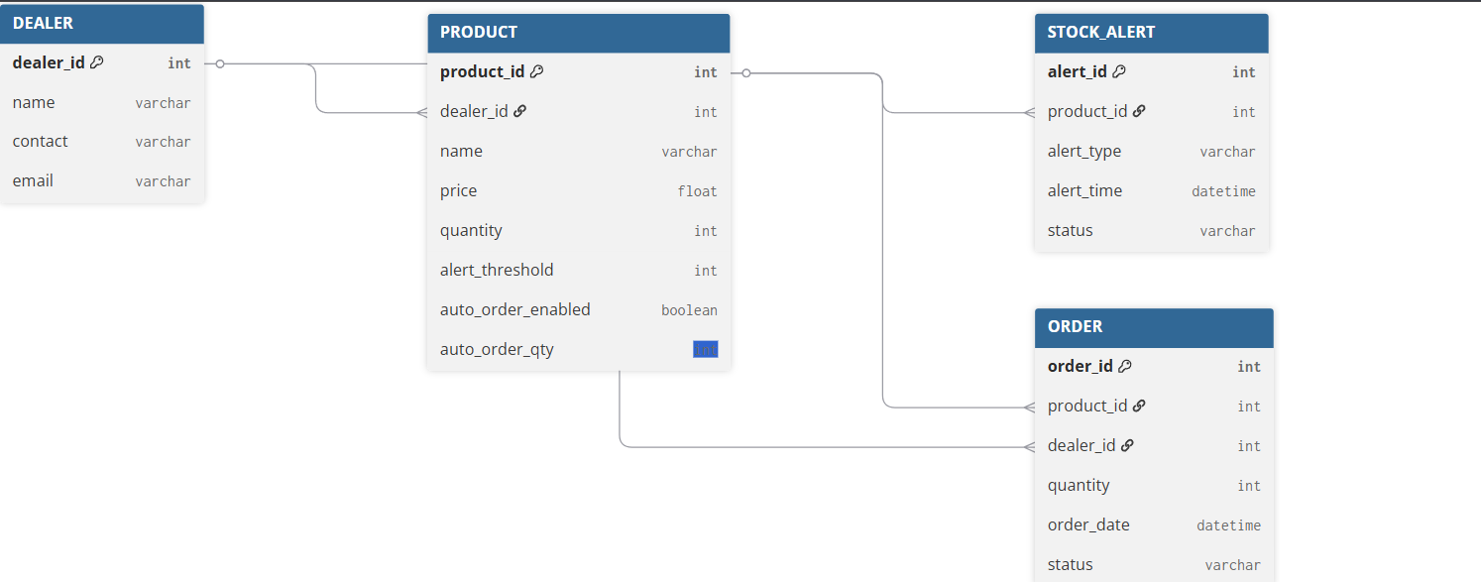
Process Flow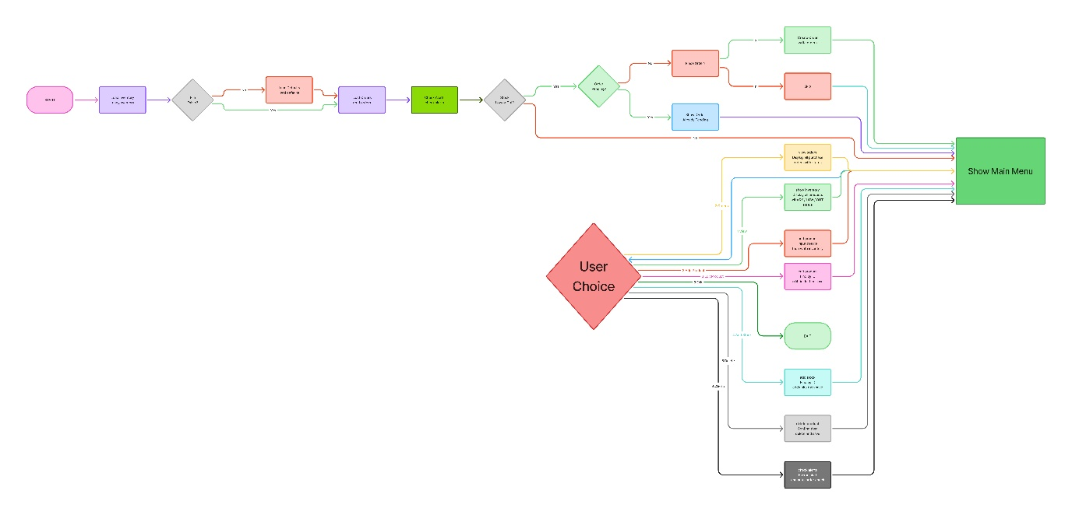
Sample Data (stock.txt – 15 Records)
ID | Name | Qty | Price | Dealer | Alert | Status
P01 | Steel Rod | 120 | 250 | MetalCorp | 30 | Available
P02 | Aluminium Sheet | 80 | 180 | AlumTrade | 20 | Available
P03 | Copper Wire | 15 | 320 | WirePlus | 20 | Low Stock
P04 | Bearing 6205 | 200 | 95 | SKF Dist. | 50 | Available
P05 | Hydraulic Oil | 18 | 410 | LubriCo | 25 | Low Stock
P06 | Drill Bit Set | 40 | 560 | ToolMart | 10 | Available
P07 | Safety Gloves | 10 | 75 | SafetyPro | 20 | Low Stock
P08 | Welding Rod | 300 | 135 | WeldSupply | 80 | Available
P09 | PVC Pipe 2in | 55 | 60 | PipeLine Co. | 15 | Available
P10 | Grease Cartridge | 18 | 220 | LubriCo | 25 | Low Stock
P11 | Hex Bolt M12 | 500 | 12 | FastenerHub | 100 | Available
P12 | Lathe Tool Bit | 25 | 480 | CutTech | 10 | Available
P13 | Rubber Gasket | 8 | 45 | SealMaster | 20 | Low Stock
P14 | Paint Grey 1L | 30 | 310 | CoatPro | 10 | Available
P15 | Cutting Disc | 60 | 85 | ToolMart | 20 | Available

Program Output
- Inventory View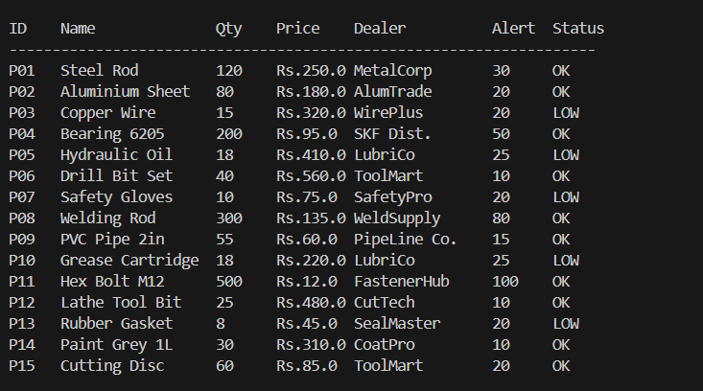
- Stock Alert
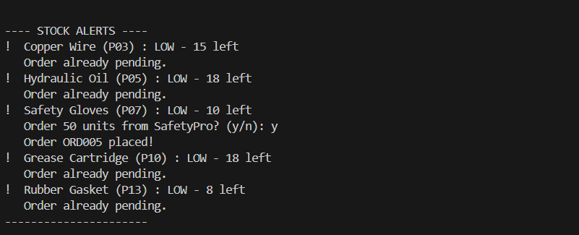
- Add new product
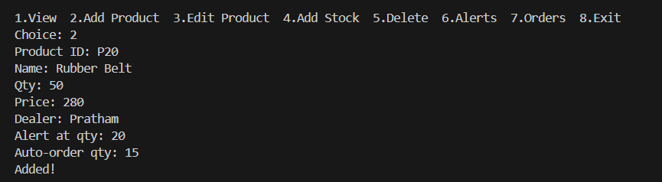

- Edit Product
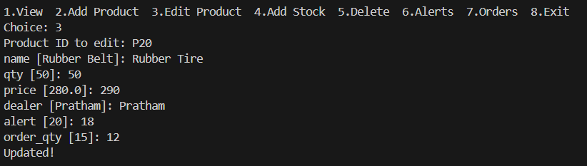
- Orders
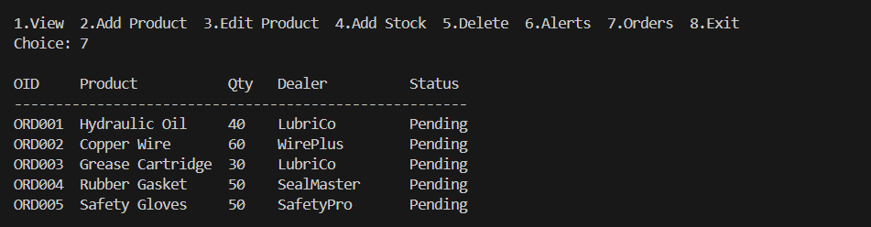
- Delete Orders
